EcoDrive Motors

**INTRODUCTION & BACKGROUND**

Ecodrive Motors is a pioneering force in electric vehicle(EV) industry, committed to delivering innovative and sustainable transportation solutions .Established over a decade ago ,Ecodrive Motors has become synonymous with cutting edge Technology, exceptional performance and environmental stewardship .The company’s diverse portfolio off EVs caters to a wide range of consumers from urban commuters to Eco conscious families .

As part of its mission to lead the translation to a cleaner future, Eco drive Motors continuously seeks to enhance its market presence and consumer reach. despite its successes the company faces a significant challenge: understanding the dynamic patterns and trends in EV adoption across different regions .The company’s executives recognized the need to comprehensively analyze available EV population data to uncover actionable insights. These insights are vital driving strategic decisions refining market targeting and improving customer satisfaction.

**PROBLEM STATEMENT**

Eco drive Motors aims to identify key factors influencing EV Adoption in various regions .By analyzing the current EV population data, the company seeks to determine trends ,understand customer preferences and pinpoint areas with high potential for market expansion .This detailed analysis will empower Eco drive motors to optimize its marketing strategies ,tailor its product offerings ,focus its regional efforts ,thereby driving growth and increasing market share.

**METHODOLOGY:**

* **Data Source:**

https://ripetizi-my.sharepoint.com/:x:/g/personal/satyaveer_ripetizi_onmicrosoft_com/EamaUFaDsJNAs8HSt3i_HI8BBmp7NuueWY5HlhnVhxnZzA?e=rVl9Ya

* **Data Cleaning:** Checked null values, duplicates, outliers

## **Tools and Technology Stack**

* **Programming Language:** Python
* **Libraries:** Pandas, NumPy, Matplotlib, Seaborn
* **Data Visualization:** Matplotlib, Seaborn
* **IDE:** Google colab
* **Version Control:** Git (for tracking changes)

**GOALS & KPI’S**

**Goals**

**Data Analysis:** Analyzing EV population data to better understand the market, target the right customers, and ultimately achieve the mission of leading the transition to a cleaner future.

**Key Performance Indicators (KPIs)**

1. **EV Adoption Rate:**
   * Percentage of EVs out of total vehicles in a specific area.
   * Tracks market penetration and adoption trends.
2. **EV Registration Growth Rate:**
   * Percentage change in EV registrations over time.
   * Measures the pace of EV adoption.
3. **Average Electric Range:**
   * Average driving distance on a single charge.
   * Reflects battery technology advancements and influences adoption.
4. **Charging Infrastructure Density:**
   * Number of charging stations per unit area or per capita.
   * Indicates charging accessibility and convenience.
5. **Incentive Utilization Rate:**
   * Percentage of eligible buyers using EV incentives.
   * Measures incentive program effectiveness.
6. **EV Model Market Share:**
   * Percentage of total EV registrations for a specific model.
   * Tracks model popularity and market dominance.
7. **Average Base MSRP:**
   * Average manufacturer's suggested retail price of EVs.
   * Reflects EV affordability and price trends.

**ANALYSIS**

**Questions and Brief Analysis (Short):**

**Q1. What is the total number of electric vehicles registered in each county?**

* + **Analysis:** EV registrations vary significantly across countie. Counties with higher registrations may have more supportive environments for EV adoption.

**Q2. Which are the top 5 most popular electric vehicle models in the dataset?**

**Analysis:** MODEL Y ,MODEL 3, LEAF, MODEL X, MODEL S are the top 5 most popular model. .

**Q3. What is the average electric range of vehicles by type (BEV vs PHEV)?**

* + **Analysis:**  BEVs have a higher average range than PHEVs, indicating their suitability for longer trips.
  + BEVs offer longer range, PHEVs provide transition.

**Q4. How many vehicles are eligible for clean alternative fuel vehicle incentives?**

* + **Analysis:**  A significant number of **17615** EVs are eligible for incentives, suggesting that government programs play a role in encouraging EV adoption

**Q5. What is the distribution of electric vehicles by model year?**

* + **Analysis:**  EV registrations have been increasing steadily over recent years, reflecting a growing market and increasing consumer interest in electric vehicles. This trend suggests continued growth in the EV market.

**Q6. Which cities have the highest number of registered electric vehicles?**

* + **Analysis:** Urban areas with supportive policies and infrastructure see higher adoption.

**Q7. What is the relationship between base MSRP and electric range?**

* + **Analysis:** **:** Higher-priced EVs generally offer longer ranges, suggesting that consumers often need to pay a premium for extended driving distances.

**Q8. Which electric utility providers serve the most electric vehicles?**

* + **Analysis:**
  + 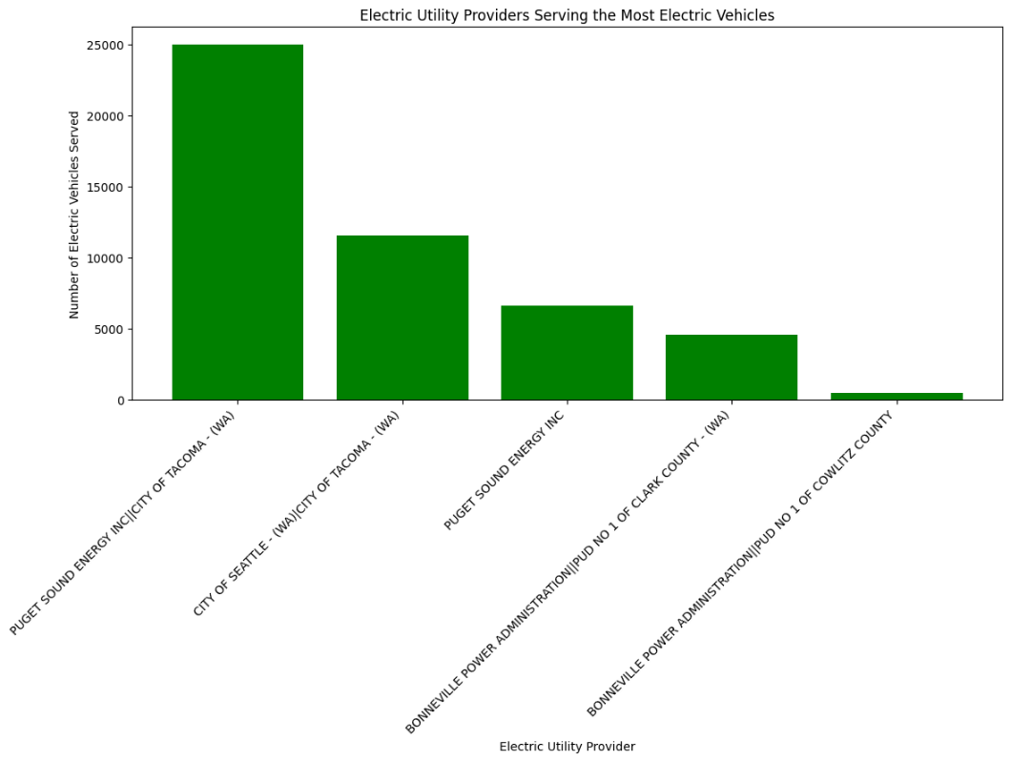

**Q9. What percentage of vehicles are plug-in hybrid electric vehicles (PHEVs)?**

* + **Analysis:**  21.47% PHEVs remain significant, offering a transition to full EVs.

**Q10. Which legislative districts have the highest EV adoption rates?**

**Analysis:**

* **Legislative District 48:**  208.9%
* **Legislative District 45:** 210.5 %
* **Legislative District 41:** 221.8 %
* **Legislative District 11: 331** %
* **Legislative District 1:**  173%
  + Adoption rates vary by district, highlighting potential for targeted policies.

**Q11**. **What is the trend of electric vehicle registration over the past 5 years??**

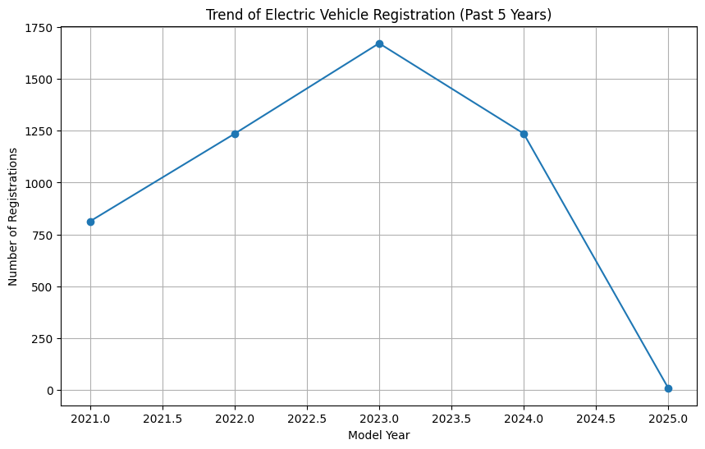

It suggests a declining trend in EV registrations. This could be due to various factors like changes in government incentives, market saturation, or shifts in consumer preferences.

**CONCLUSION**

**Key Findings**

* **Regional Disparity:** EV registrations vary significantly across counties, indicating uneven adoption rates.
* **Model Popularity:** Model Y, Model 3, Leaf, Model X, and Model S are the most popular models.
* **Range Advantage:** BEVs generally offer longer ranges than PHEVs.
* **Market Growth:** EV registrations have been increasing steadily over recent years, indicating a growing market.
* **Urban Concentration:** Urban areas with supportive policies and infrastructure tend to have higher EV adoption rates.
* **Price-Range Relationship:** Higher-priced EVs generally offer longer ranges.
* **PHEV Significance:** PHEVs constitute a significant portion of the market, offering a transition path for consumers.
* **Legislative District Variations:** EV adoption rates vary significantly across legislative districts.

**Recommendations**

* **Targeted Incentives:** Implement targeted incentives and policies in counties with lower EV adoption rates to stimulate growth.
* **Infrastructure Development:** Invest in expanding charging infrastructure, particularly in areas with high EV concentration and along key transportation routes.
* **PHEV Support:** Continue to support the development and adoption of PHEVs as a transition technology.
* **Data-Driven Policy:** Leverage data analysis to inform policy decisions and allocate resources effectively.
* **Legislative District Focus:** Implement policies that address the specific needs and challenges of legislative districts with lower EV adoption rates.
* **Market Analysis:** Continuously monitor market trends and adjust policies and incentives accordingly.
* **Consumer Education:** Educate consumers about the total cost of ownership of EVs, including energy costs and maintenance.